My Spark Social Channels Post Content Break Down:

Facebook (Final Draft Submission):

3 stock pics of kids doing the things one solo and two group pics. 1 image of the $1000 promo graphic. I have made a new one.

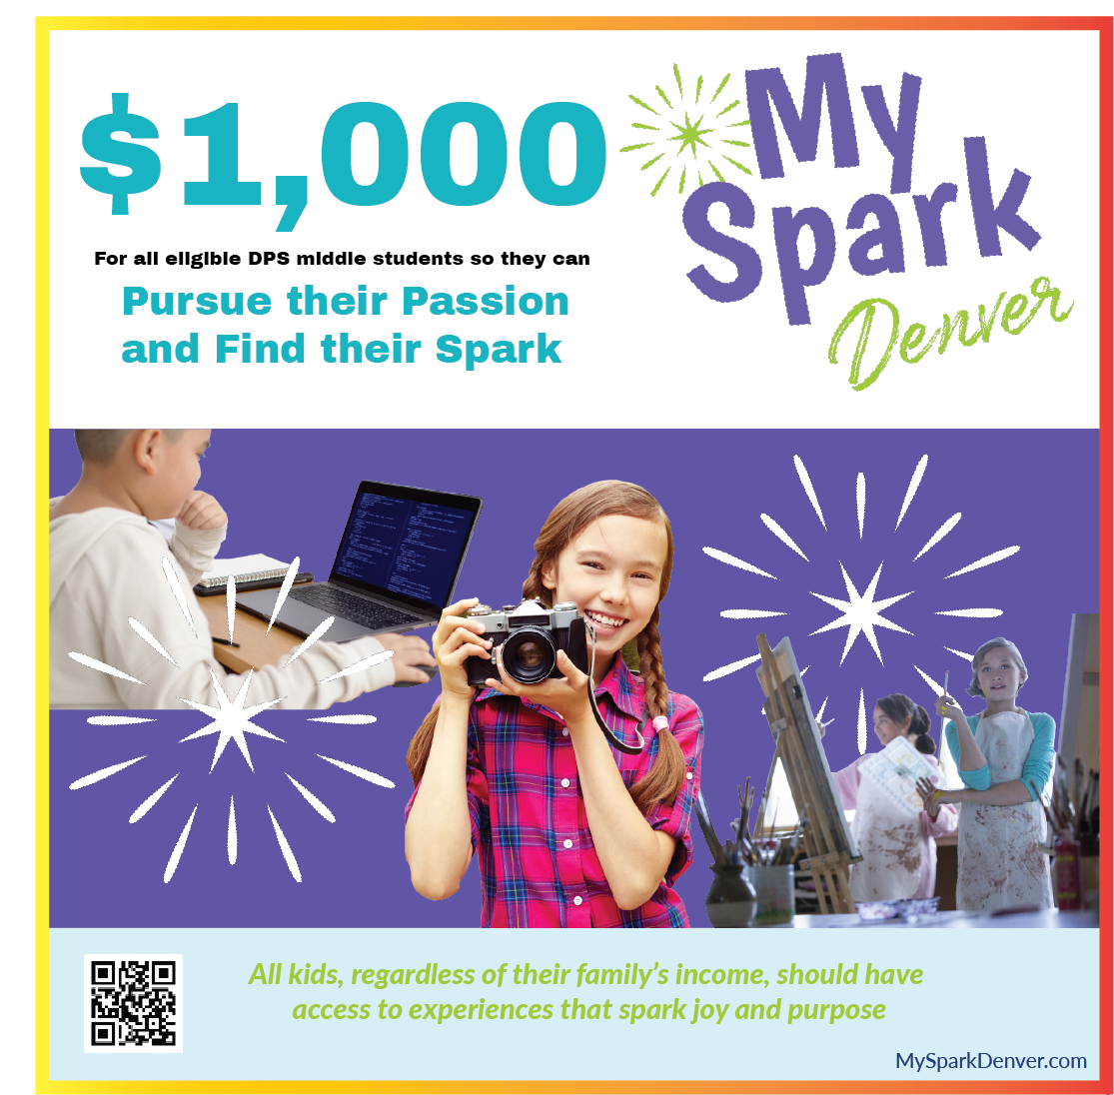

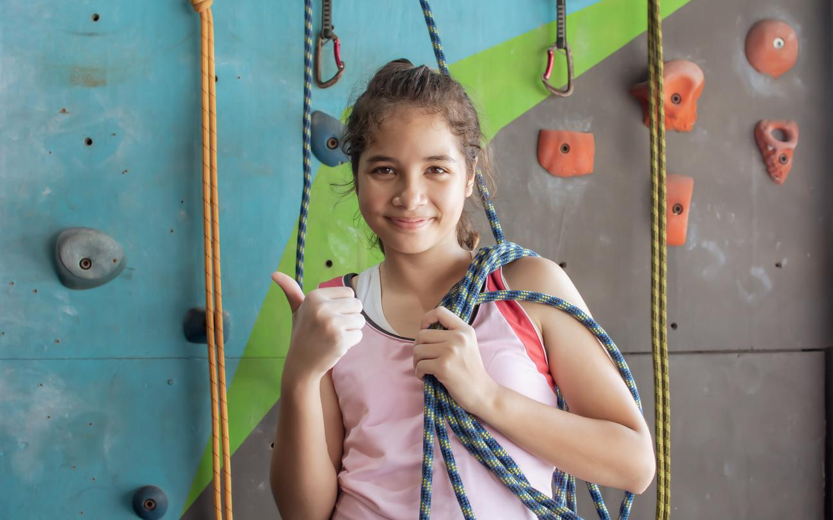

#MySparkDenver
#DenverAfterschool
#DenverExtracurricular
#afterschoolmatters
#DenverPublicSchools
#communityfocused

#add a # for whatever activity is featured in the photos

Tags: Are there any individuals, groups or orgs that I should tag in the caption?

FB Post Caption Copy (Final):

Attention DPS middle schoolers and parents! Trying to find a fun extracurricular activity, but worried about the cost? Would $1,000 make it easier to figure that out? DPS middle school students whose families qualify for free and reduced-price lunch can sign up for My Spark Denver and receive a $1,000 debit card to enroll in extracurriculars! Apply online today.

Instagram (Final Draft S RFP Social Media Copy Development for Marketing Campaign – T3 October 2023
ubmission):

3 pictures. 1 of group, 1 of activity participation, 1 of the $1000 marketing poster.
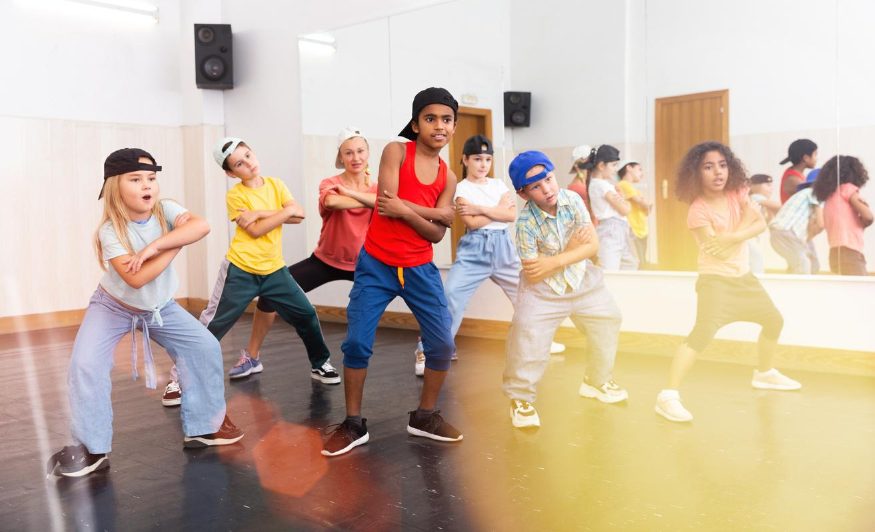



#MySparkDenver
#DenverAfterschool
#DenverExtracurricular
#afterschoolmatters
#DenverPublicSchools
#communityfocused

#add a # for whatever activity is featured in the photos

Tags: Are there any individuals, groups or orgs that I should tag in the caption?

IG Post Caption Copy (Final):

Trying to find a new activity to try outside of school? Would $1,000 interest you? Are you a parent or student of a DPS middle school? Then you should click the link below and apply for My Spark Denver today! We have a huge list of activities to choose from all across the city and you can pay for any of them using the $1,000 when you apply and are approved. So what are you waiting for?

