CONTACT: Nita Gonzales | Principal, Nuevo Amanecer LLC | (303) 229-2124 | Nita@nuevoamanecer.biz

WHAT: Dias de los Muertos is an ancient indigenous ceremony meant to honor the lives and legacies of our friends and family members who have passed on from this world, with traditional dance, poetry, food, and community gathering. It is both a celebration of the cyclical nature of life and death together and a time to invite our ancestors to walk among us so they know we have not forgotten them.

WHO: Activist Nita Gonzales of Nuevo Amancer, Denver District 1 Councilwoman Amanda Sandoval, Denver District 4 Councilwoman Serena Gonzales-Gutierrez, and Carlos Castaneda, director of Grupo Tláloc Danza Azteca.

WHEN & WHERE: DENVER, CO - Wednesday, Nov. 1 2023

- 5:00 PM MST - Troy Chavez Memorial Peace Garden
  - 3825 Shoshone St
  - Ritual blessings and traditional dance.
- 5:30 PM MST - Procession from the Peace Garden to La Raza Park
  - Neighborhood: Sunnyside
- 6:00 PM MST - Arrive at La Raza Park:
  - 1501 W. 38th Ave
  - Traditional blessing of 27 sacred altars.
  - Followed by celebration with food, dancing, music, poetry, and communion with our ancestors

WHY: To preserve sacred ceremony, cultural heritage, and spiritual significance and to prevent its erasure by Western Colonialism. To honor our ancestors, and to share our culture with our neighbors throughout Denver.

- The roots of Dias de los Muertos celebrated in contemporary Mexico and among those of Mexican heritage in the United States and around the world, go back some 3,000 years, to the rituals honoring the dead in pre-Columbian Mesoamerica. The Aztecs and other Nahua people living in what is now central Mexico held a cyclical view of the universe and saw death as an integral, ever-present part of life.

"Día de Los Muertos at La Raza Park is not just a celebration; it's a profound connection to our roots and a beautiful tribute to those who came before us. It's a day when the past comes alive, reminding us that our ancestors are never truly gone; they live on in our memories, the stories we tell, and the vibrant traditions we proudly uphold."
- Nita Gonzales

"Día de los Muertos at La Raza Park is not just a celebration; it's a powerful testament to our cultural heritage and a profound connection to our ancestors. In this vibrant tapestry of remembrance, we honor the past and celebrate the present, reminding ourselves that the spirits of our loved ones live on in our hearts and the rich traditions we uphold."
- Carlos Castaneda, Grupo Tláloc



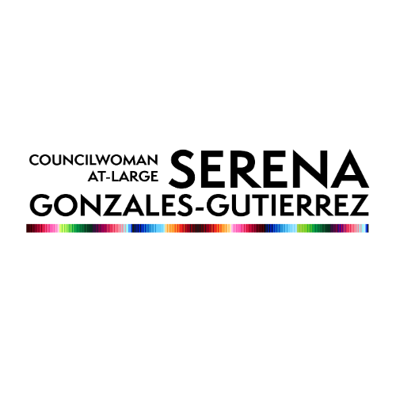
To learn more about Dias de los Muertos - you can check out this video on YouTube by Beautiful Destinations.

